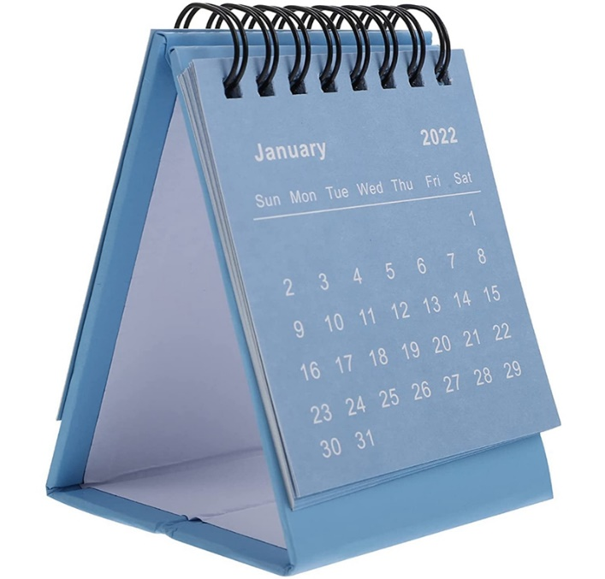**TABLE CALENDAR**RYANA CALENDARS is selling wonderful CALENDARS !at reasonable prices. IT has perfect designs and color combinations.

**RS 230**